ROLL NUMBER:21l-5654

Muhammad Hamza Khan

Lab 4:

Task 1

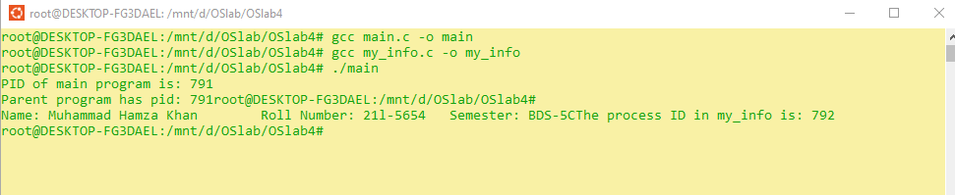

Task 2:

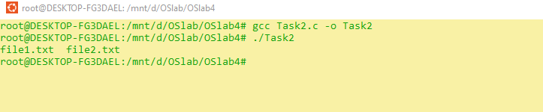

Task3:

